
Construct terrain brush.

Pixel editing.  Having drawn on paper a very rough sketch of the level geometry that I wanted to create with a good idea of what heights each part would have, I created a 32x32 bitmap with a full 256 colour palette, and set about the rather lenghtly task of placing the correct colour from the palette into the correct pixel location of the bitmap.  This technique I admit takes some time, but I believe well worth it and the end results often prove it, as usual my believe is that nothing worth while can be done in a few seconds.  So from my drawing I set the base level of the ground of my habour, the darkest blue, then stepped up the index value by choosing a colour higher within the palette for some contouring, a very important point here is that adding pixels in pairs is a must do to enable a later process of polygon removal of basically the ability of lessening the viewable poly count dramically by making any square polygons which are connected and on the same level, combining them by brush de-intersection.  Another very important part of this process is to add pixels of the same index value in groups of two or more this again is important for game play and to lessen any BSP engine issues, navigation around a level is much easyier running up slopes to flat levels, so avoiding inverted cones is important.  But I do recommend that anybody trying this method spend a bit of time experimenting with this and that , change pixel values, re-import, change, re-import I tend to do this with both applications loaded side by side so with a few mouse clicks you can view the terrain as it all comes together.  A small piece of advise here, I found it rather irritating having to re-input the same numbers into TerraEdit all the time ie for me a grid scale of 64 and grid size of 32x32, I found the quickest method was to double click the numerical input boxes hence high-lighting the numbers in the usual windows way. Those some quick numeric key pad hitting and your done, a bummer also is that dialog box doesn't allow the tab key to navigate to the next field.... Arrrrrghhhhh.  Another very important part if this terrain design method is to pay extreme care of the possible polycounts that could be viewed from all possible locations, so I tend to use lots of view blocking, so make sure that a player can't see all of the level at once from anywhere.  Trial and error works well, and I guess experience helps, I have many times have had to import the t3d file UnrealEd, do what is necessary to make the brush a playable level, this oddly enough takes very little time... here are a list of the steps, there is a full blown step-by-step guide on page 5 of this tutorial. Import t3d file, add it, rotate it 180, transpose about the y axis, scale it to your size requirements, make a cube to encompass the whole terrain brush allowing for some head room, subtract the cube brush, re-order the terrain brush to last, rebuild & save, texture all polys of both brushes via the Shift_B short-cut, add a player start, a zone actor and set the zone light to max, set the main level game type properties to be a UTIntro game, rebuild, save and play, you may need to use the "iamtheone" console command to enable you to fly, then walk again, basically look around the whole terrain noting which areas give high poly counts.  For this type of level I recommend a average poly count no higher than 100-140, but this of course depends on what else you intend of adding to your level later.  But I am sure that you cunning designers can hide stuff away, maybe have sub-terrainiun buildings, bunkers, etc etc, level design in my opinion allows for infinate amounts of creativity...  Remember that slopes higher than a certain angle would be impassable to a human player or bot, hummm bots that reminds me I have found over the months path noding levels like these getting bots to climb steep long slopes is rather a challenge, so you have been warned if this indeed happenes when path noding some well placed bridges soon gets the bots going about their business as usual.  I was lucky I managed to do the whole process, within a few hours, build a test unr file just once found all the bad areas, redid the bitmap to reduce and enhance the terrain, then re-imported the t3d file again, ready for the next tutorial "UnrealEd Terrain brush manipulation" how to use UnrealEd to improve the terrain even more, reducing the poly count dramatically. | 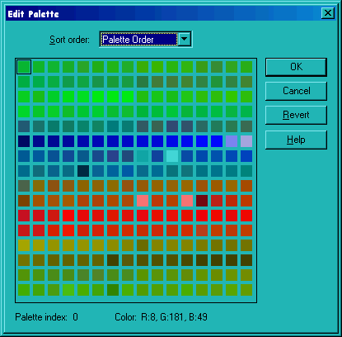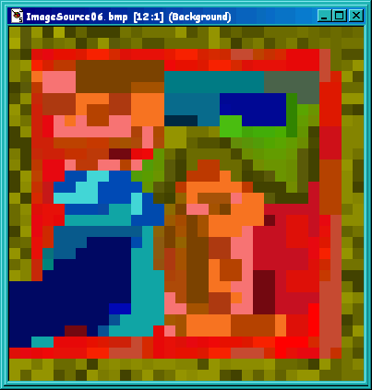

TerraEdit Screen shoots.
